Node.js: Beginner to Advance

#1. Basic Before Getting Start:

* What are Client & Server Side?

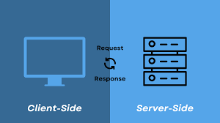

* + **Client-side:**

Actions take place on the user's computer,

such as running scripts in a browser.

* + **Server-side:**

Actions take place on the web server,

such as generating dynamic HTML pages

* Where do we use node (Client or Server Side)?

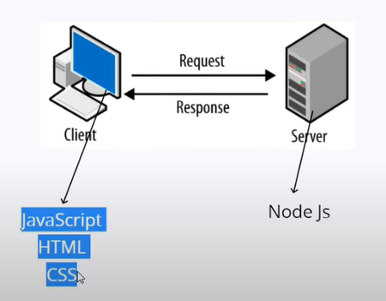

* How Node.js use JavaScript?

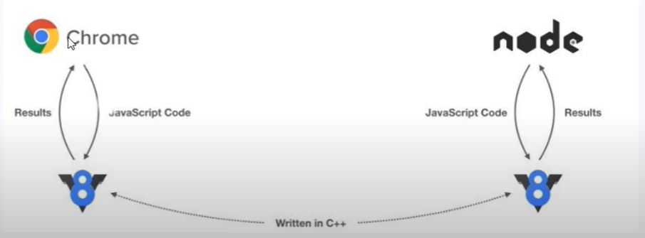

* What developer Make with Node.js?
  + Developers Make API with Node.js
  + So we can connect Server with Client.
  + Node can make API for web, Android & IOS etc.
  + Make can also make website.

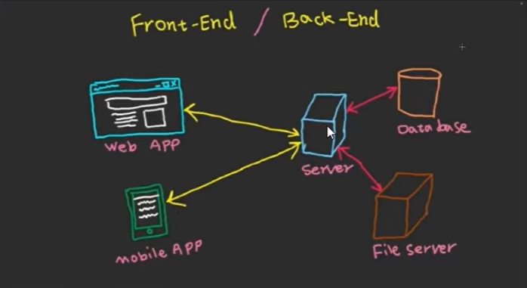

#2. First Script With Node:

* Script with Command line:

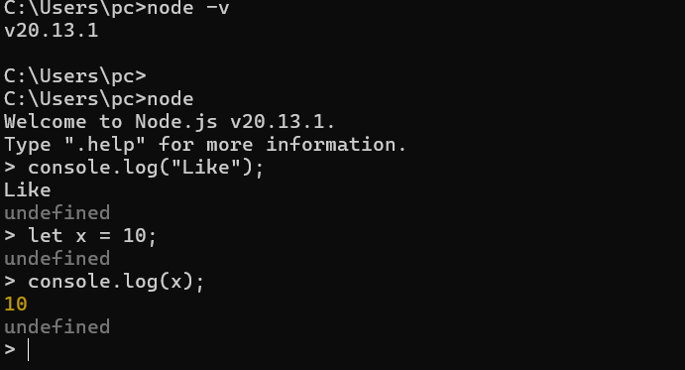

If there is statement with no return then it is showing undefined.

* Make Folder and File &, Write First Code & Run

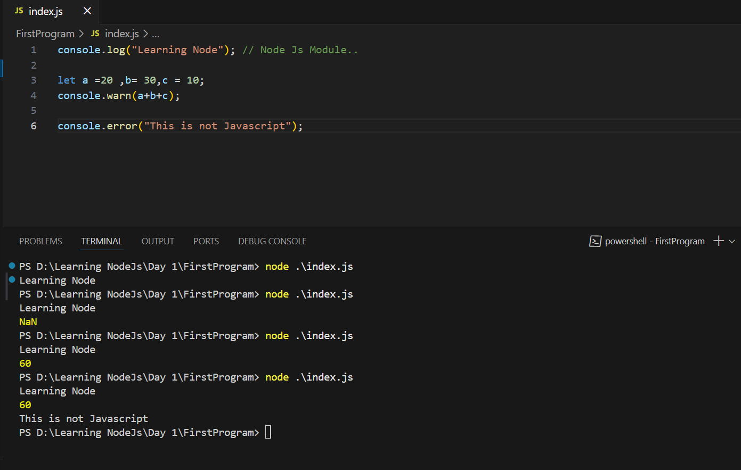

#3. Fundamentals Of Node.js:

* Javascript Fundamentals for Node.js
* Conditions, Loops, & Array.
* The import Function & variables from another file.

Folder name: FirstProgram/index.js & app.js..

#4. Core Module in Node.js:

* What are the core Modules?

Core modules in Node.js are built-in modules that are bundled with Node.js and do not require external packages to be installed.

* What are the global Modules?

A global module in Node is a module that's used in more than one template. For example, a website footer could be a global module.

* Global Model example

myGlobalModule.js

// Define a variable and a function in the global scope

global.myGlobalVariable = "Hello from global module!";

global.myGlobalFunction = function() {

console.log("This is a global function!");

};

App.js

// Access the global variable and function

console.log(myGlobalVariable); // Output: Hello from global module!

myGlobalFunction(); // Output: This is a global function!

* Non-Global Module with Example.

In Node.js, a non-global module refers to a module that is not installed globally using the -g flag with npm. These modules are installed locally within a project's directory and are only accessible within that project.

Here's an example of a non-global module in Node.js:

1. Create a project directory and initialize it:

Code

mkdir my-project  
cd my-project  
npm init -y

2. Install a non-global module (e.g., Lodash):

Code

npm install lodash

3. Create a JavaScript file (e.g., app.js) and use the module:

JavaScript

const _ = require('lodash');  
  
const numbers = [1, 2, 3, 4, 5];  
const sum = _.sum(numbers);  
  
console.log(sum); // Output: 15

4. Run the script:

Code

node app.js